POSITION DESCRIPTION

Position Title: | Volunteer Programs Coordinator
Business Unit: | [YOUR ORGANISATION].
Reports To: | Manager
Classification: | Common Law Contract
Date Prepared/Updated: | July 2022

[YOUR ORGANISATION]
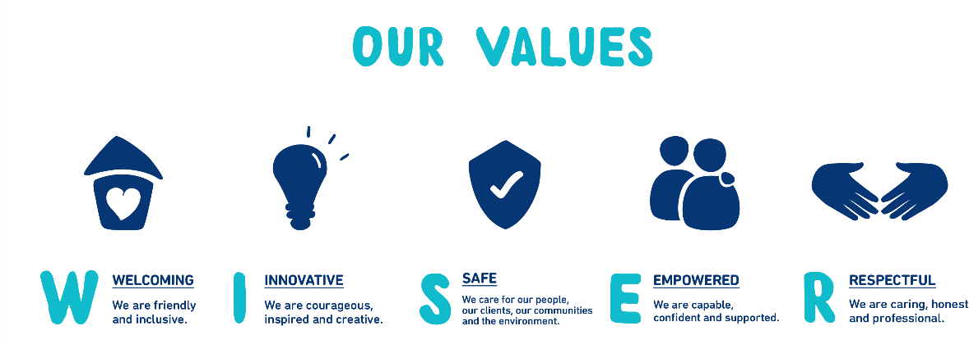

It takes a competent leader to succeed in this type of work. You should know how to distinguish volunteer talent and do everything possible to motivate and inspire.
You need excellent organisational skills and ability to communicate with people from diverse backgrounds and experience in a very fast paced environment.

[YOUR ORGANISATION] is an equal opportunity employer that understands and values the importance of creating a diverse and inclusive work environment. We are committed to making reasonable adjustments to provide a barrier-free recruitment process for people with a disability.

Position Purpose
The purpose of the Volunteer Coordinator is to provide volunteers with an exceptional volunteer experience across each stage of their engagement lifecycle.
Key Accountabilities of Role
The position is directly responsible to the [YOUR ORGANISATION] Manager for key accountabilities and the achievement of Key Performance Indicators.

Key Result Areas:
- Deliverance of high-quality volunteer and student experience at [YOUR ORGANISATION].
- Recruitment and training of volunteers, ensuring compliance with worker screening policy and quality and compliance regulation.
- Matching volunteers to opportunities across [YOUR ORGANISATION] that suit their goals, interests, and skills.
- Support volunteer growth and development, providing supervision, feedback, and support, at key points of their engagement.
- Coordinate volunteer probationary and annual performance reviews in conjunction with host business areas.
- Assist in the delivery of volunteer recognition initiatives including formal events that celebrate volunteer achievements.
- Empower and champion volunteers and students who are motivated to [YOUR ORGANISATION], to gather experience and navigate pathways to paid employment where suitable.
- Promote the growth of the volunteer program through the regular advertising of opportunities through various community and education sector channels.
- Liaise with business and community stakeholders to encourage volunteer and student involvement.
- Actively support continuous improvement of the volunteer program through our feedback and evaluation framework.

General:
- Develop and maintain effective working relationships with relevant individuals, [YOUR ORGANISATION] entities and external organisations
- Excellent communication demonstrated by high quality written and verbal skills
- Positive pro-active approach to client service delivery and the ability to develop productive relationships with all stakeholders to achieve assigned tasks
- Complete work in a fast-paced team environment where competing priorities and changes are constant
- Apply educated decision-making skills
- Provide high level administration services to support the operations of the Volunteer Program.
- Ability to work within a budget and complete financial purchasing and invoicing relative to the Volunteer Program Department, under supervision of the Manager.
- Undertake projects and other associated duties as directed
- Apply effective time management and prioritising skills to meet deadlines and complete work
- Display high level of personal integrity and professionalism when representing [YOUR ORGANISATION]
- Demonstrate confidentiality and sensitivity about matters
- Adhere and apply all [YOUR ORGANISATION] Policy and Procedures including OH&S
- Attention to detail in completion of accurate and timely work
- Prepare reports, PowerPoint presentations and other display work for seminars and functions
- Always follow [YOUR ORGANISATION]’s Code of Conduct
- Undertake projects and other associated duties as directed
- Other duties as directed by manager or supervisor

Key Working Relationships: | Internal:  - Volunteer Programs Staff  - Staff across [YOUR ORGANISATION].  - Volunteers and students across [YOUR ORGANISATION].  External:  - Local Community Members  - Education and Training Stakeholders  - Corporate Services  - Government agencies and third parties as required
Key Selection Criteria & Qualifications: | Qualification:  Essential:  - Relevant experience and/or tertiary qualifications in human resources, and social sciences, or similar.  - Broad experience and relevant tertiary qualifications in collaborating with people in a medium to large organization.  - Genuine passion for collaborating with people  - Exceptional interpersonal and communication skills with the ability to build effective and positive relationships with internal and external stakeholders at all levels  - Ability to communicate with varied audiences including the capacity to deliver training  - Good understanding of volunteer and student placement programs  - Positive pro-active approach to service delivery  - Ability to engage with and support volunteers from a diverse range of backgrounds and experience  - Proven experience in administrative skills including proficiency in all Microsoft Office Programs  - A high level of confidentiality and sensitivity regarding all matters  - The ability to work unsupervised on projects  - Proven ability to prioritise and organise to meet deadlines whilst working under pressure  - Attention to detail including literacy and numeracy skills  - Ability to work in a team  - Fulfils inherent requirements of position including physical requirements, role challenges and essential requirements  Desirable:  - Comprehensive knowledge of the Australian National Standards of Volunteer Involvement.  - Previous experience in volunteer coordination  - Previous experience in the use of volunteer management  - Working with Children check.  - First Aid Certificate.

Cultural Fit: | In addition to the selection criteria outlined above, the successful applicant must be able to demonstrate they are committed to the [YOUR ORGANISATION]. Vision, Mission and Values and will bring a collegial approach to the [YOUR ORGANISATION] workforce and incorporate these values and behaviours.  [YOUR ORGANISATION] values diversity and encourages applications from Aboriginal and Torres Strait Islanders, people with disabilities and from culturally and linguistically diverse backgrounds. [YOUR ORGANISATION] is committed to making reasonable adjustments where operationally viable.
General Information: | Employment terms and conditions are provided according to relevant award/agreement.  This position description is intended to describe the general nature and level of work that is to be performed by the person appointed to the role.  It is not intended to be an exhaustive list of all responsibilities, duties and skills required. [YOUR ORGANISATION] reserves the right to modify position descriptions as required. Employees will be consulted when this occurs.  [YOUR ORGANISATION] recognises the increased importance of workplace flexibility and will reasonably consider requests for flexibility to balancing work, life, and family needs.  [YOUR ORGANISATION] is proud to be a child safe organisation with the [YOUR ORGANISATION] “Keeping Children Safe” policy and adherence to the national child safe  standards.

